SPM INSTALLATION GUIDE

Document N.: SPM Installation Guide

Revision: 1.0

For further information please contact:

info[@uppwise.com](mailto:i.pirovano@projectobjects.com)  
[www.uppwise.com](http://www.uppwise.com)

Table of contents

1. Overview 2

2. SPM Installation Requirements: 2

3. Configure version on server machine 3

4. How to Create Application SPM POOL 6

5. Assign Application SPM POOL To Your Application 8

6. Gantt Editor Configurations 8

7. SPM Database configuration 12

8. Volt Database configuration 19

9. Web.Config Setting 26

# 

# Overview

This document is primed to describe the installation process for SPM version of application over On-Premises customers.

# SPM Installation Requirements:

System must be equipped with the below mentioned software prior to the installation of SPM Application:

|  |  |
| --- | --- |
| **Component** | **Minimum** |
| Access | Remote desktop or Web-ex or TeamViewer Sessions details before scheduled time. |
| Server | Window Server 2019 R2 Enterprise |
| Processor | 3.10 gigahertz (GHz) |
| RAM | 56 Gigabyte (GB) |
| Disk | NTFS file system–formatted partition with a minimum of 3 GB of free space |
| Display | 1366 × 768 |
| Network | 56 kilobits per second (Kbps) connection between client computers and server |
| IIS | IIS server 10 |
| IIS Folders | Read and write access of the folder C:\inetpub\wwwroot\ |
| SQL Server | SQL Server 2016 |
| Framework | Dot net framework 2, 3.5, 4, 4.5, & 4.7.2 |
| ASP.NET Core SDK | 3.1 & 6.0 |
| ASP.NET Core Runtime | 3.1 & 6.0 |
| Windows Server Hosting | 3.1.3 & 6.0 |
| ImageMagick-7.0.2-Q16 | To be installed on the Application server. Provide read and write access to everyone on the installed folder. |
| Phantomjs-1.9.2-windows | To be copied on an application server with reading and write access to everyone on the copied folder. |
| JDK | Java 8.0 |

# Configure version on server machine

**Step 1**: Copy the published version of applications to folder **"***C:\intepub\wwwroot***"** *[default]* folder.

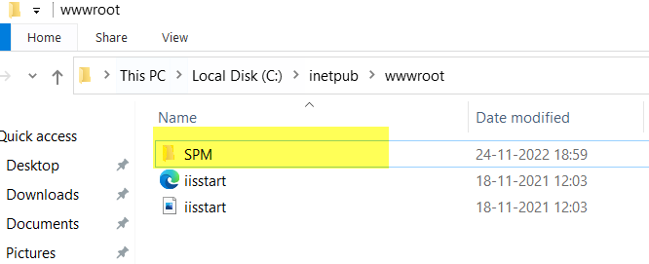

***Note:*** Application folder name can be different on Server.

**Step 2:** Give full access to **temp** folder of application. We must add “everyone” as a user and give Full Control. Refer below screens:

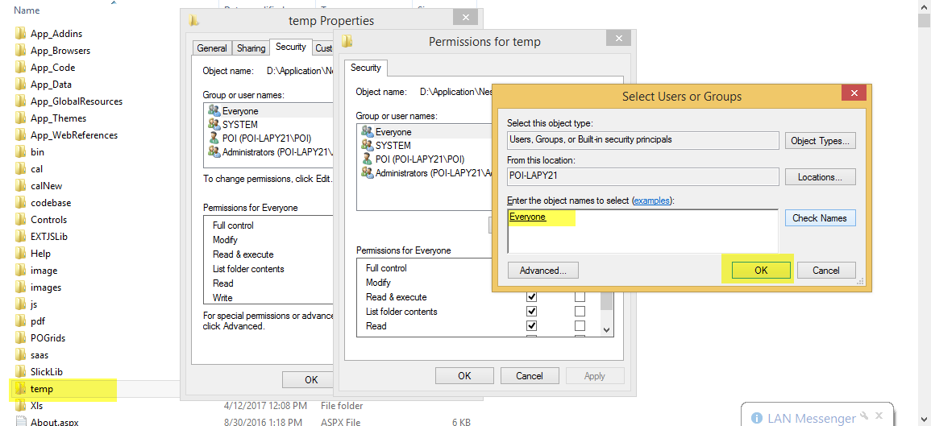

**Step 3:** Give full access to **JsonData** folder which is under **SlickLib** folder of application. We must add “everyone” as a user and give Full Control. Refer below screens:

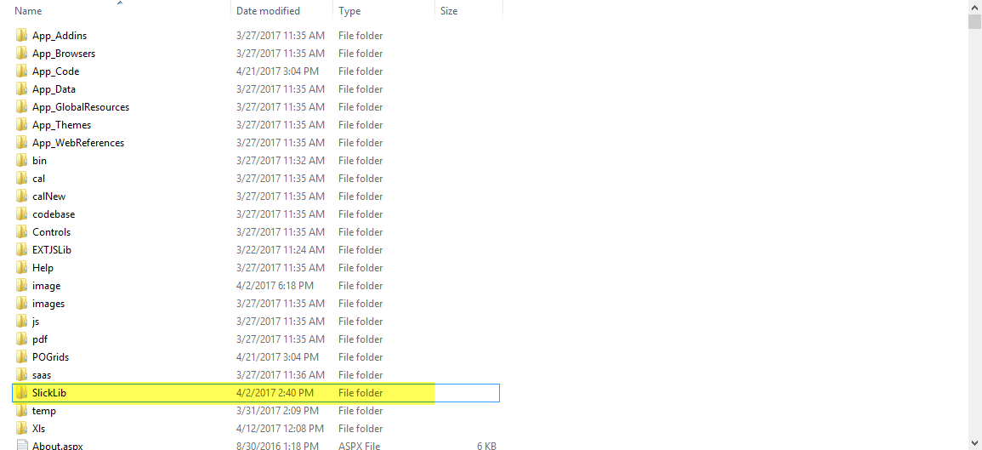

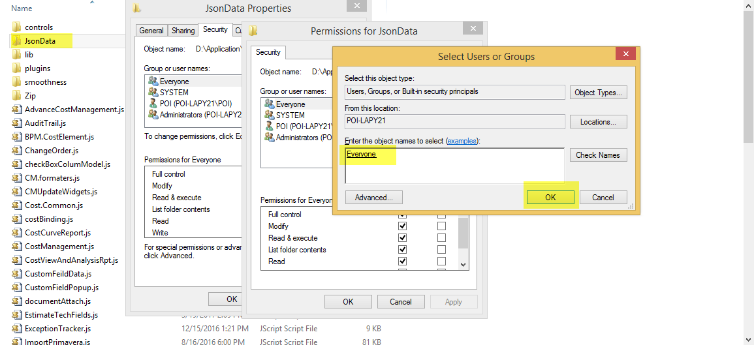

**Step 4:** From **RUN** - > inetmgr -> OK

The following screen will come. This is the main page for any application. There are three panels.

***“SPM Application”***folder will then display as highlighted in above screen.

**Step 5**: We need to convert folder to an application. Right click and then select "ConvertToApplication" as shown in the following picture:

After converting it to application, its icon will be changed and then you can set the property for your web application from the middle pane. You can set IIS Authentication Mode, Default Page Just like IIS 6.0:

You can change Security Settings on Authentication Section. By default Setting will be set from your web.config itself. As in my web.config Form Authentication was set that's why, Forms Authentication has been enabled. If we want to change the status, just double click and update status to Enabled, to Disabled or Vice Versa.

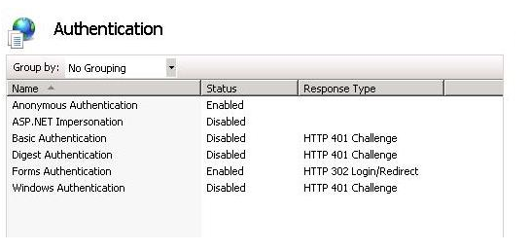

# How to Create Application SPM POOL

A site can contain many applications including that site’s default application, which is called the root application. In addition to belonging to a site, an application belongs to an application pool, which isolates the application from applications in other application pools on the server.

**Step 1**: Right Click on Application Pool and give the name of your pool. Here, I have given "Pool" and select Framework and click on OK:

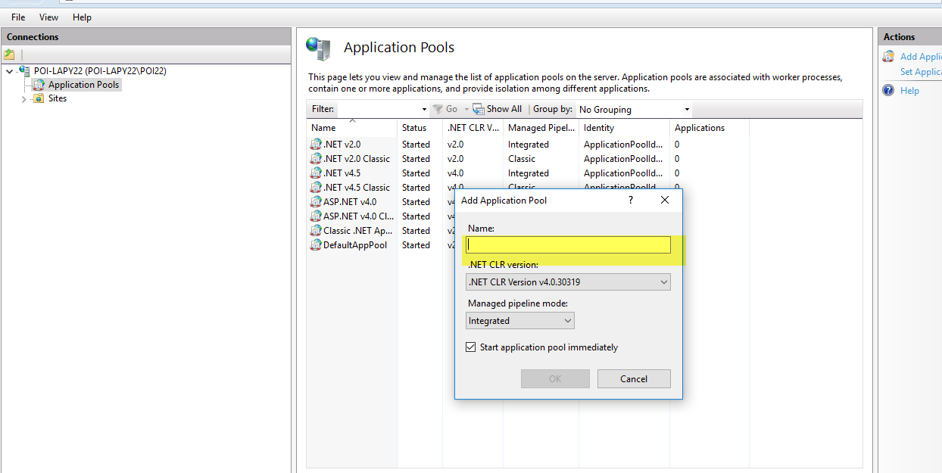

**Step 2**: If you are writing something on the server [may be writes Error Events Logs], you need to change the Pool Identity to Local System. Right click on Pool Identity setting as shown in the following image:

There are three identities of Application Pool:

* Network Service
* Local Service
* Local System

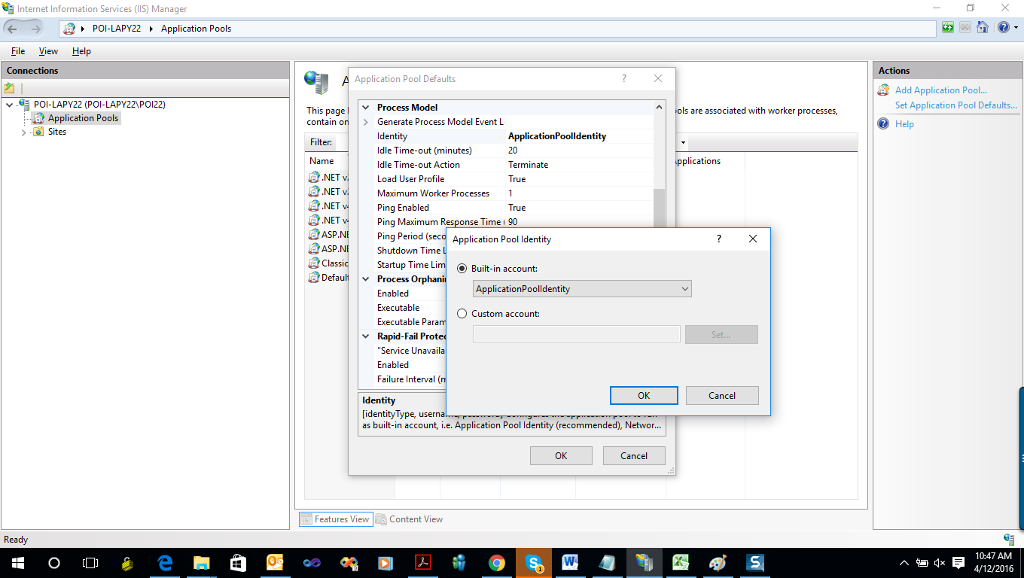

# Assign Application SPM POOL To Your Application

Now, we need to assign the Application Pool to our web application.

**Step 1**: Right Click on Application and Select *"Advanced Settings"*:

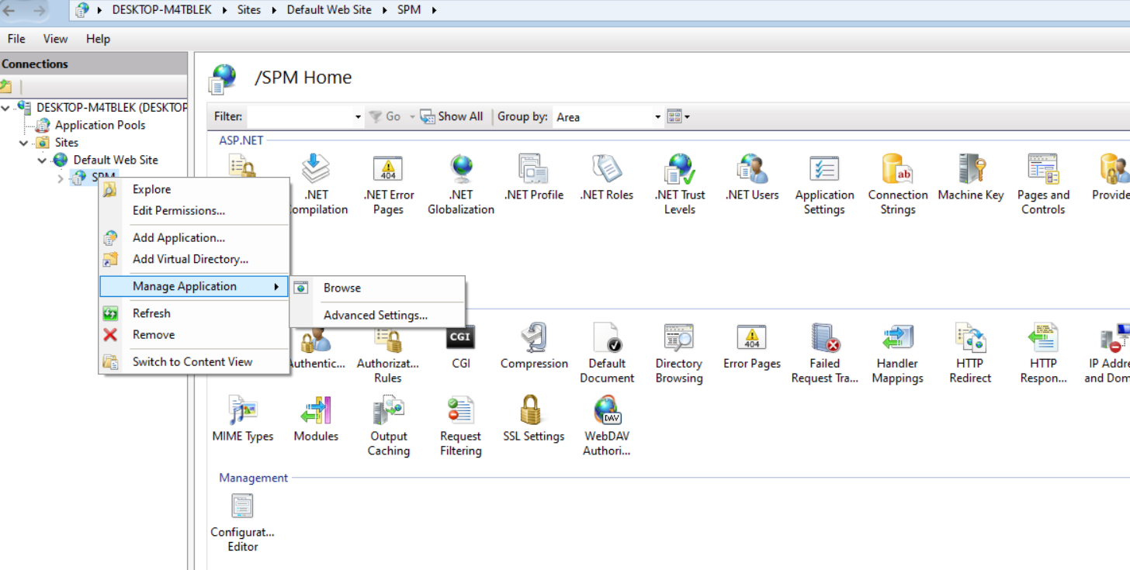

**Step 2**: Finally assign your created Application Pool or Existing Pool “ASP.NET **v4.0 Classic”** for "**SPM"** Application.

# Gantt Editor Configurations

Following need to be installed on Application server of customer:

* ImageMagick-7.0.2-Q16
* Phantomjs-1.9.2-windows

**Step 1:** InstallImageMagick setup on application server.

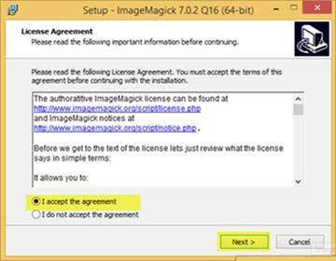

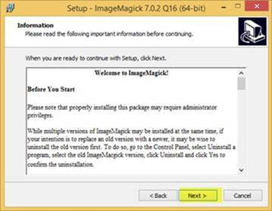

**Step 2:** Provide Path

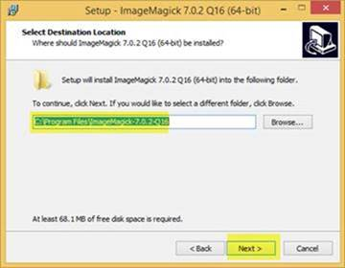

**Step 3:** Select all checkboxes

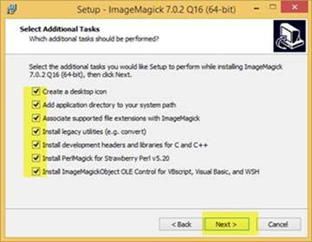

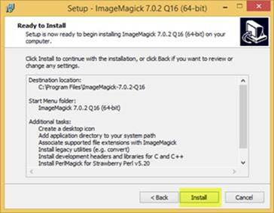

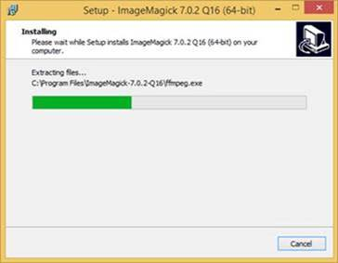

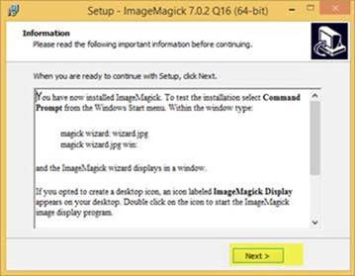

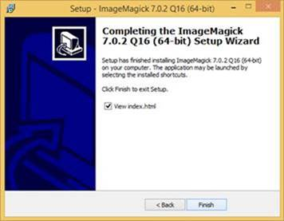

**Step 3:** Copy Phantomjs on application server.

**Step 4:** Provide full writable access of folders to Everyone, where ImageMagick and Phantomjs is installed.

**Step 5:** Location path of foldersthenneed to be provided in respective keys in web.config. Please refer to below screen:

id:image003.png@01D239F9.F45F1E40

# SPM Database configuration

Below process need to be followed when a new database is configured.

**Step 1:** Open “SOL Server Management Studio”. A Pop-up will appear then click on “connect” to connect to the server. Enter SQL credentials to connect to SQL.

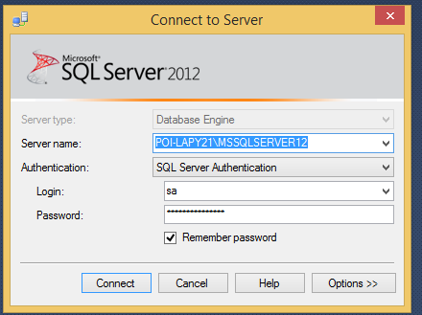

**Step 2:** Right click on “Database” menu at the left frame of the window. Then select “New Database”.

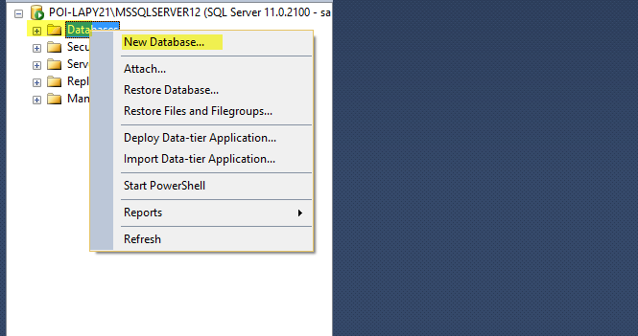

**Step 3:** Now enter the Database name and click on OK button.

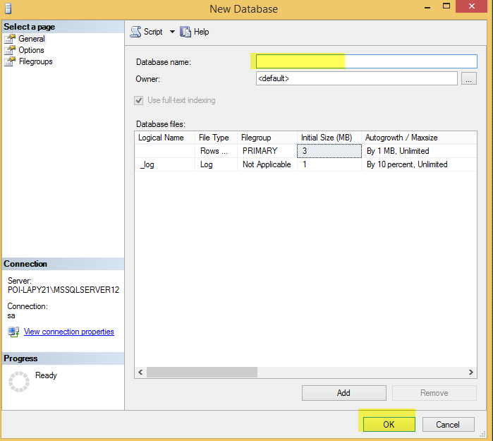

**Step 4:** Right click on the Saved DB name > Select Task > Select Restore > Select Database. As shown in below screen:

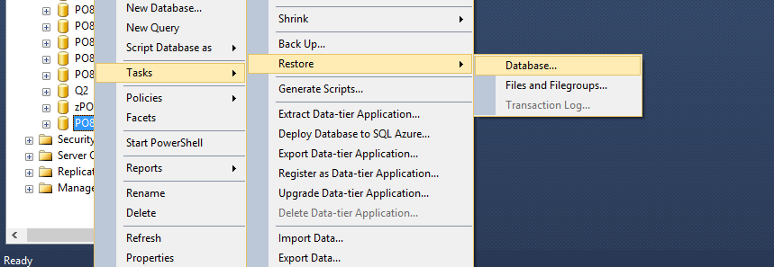

**Step 5:** Restore Database window will open. Select **Device** and click on **Select Device** icon, this will open Select backup devices window as shown below:

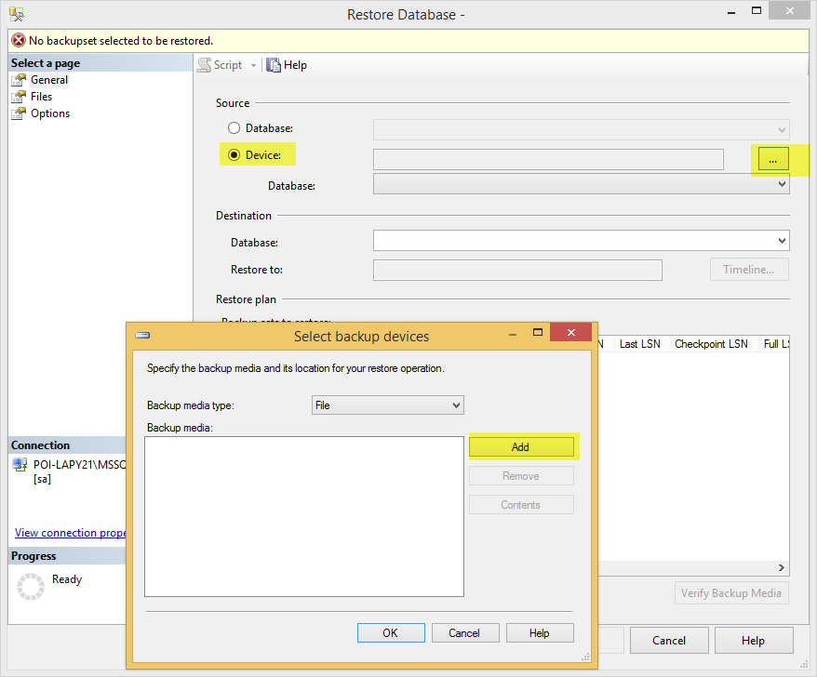

**Step 6:** Click on the Add to select the location where database is saved. After database is selected click on OK button.

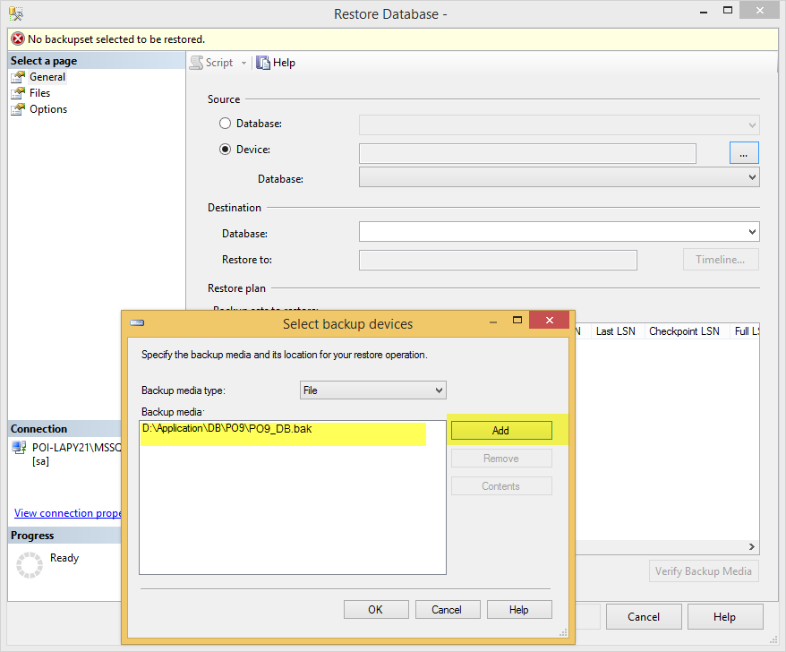

**Step 7:** In Database dropdown highlighted below, select the saved DB name to be configured. And check restore checkbox.

**Step 8:** Go to Files Tab and select respective location of .mdf file and .log file which is creation with same DB name.

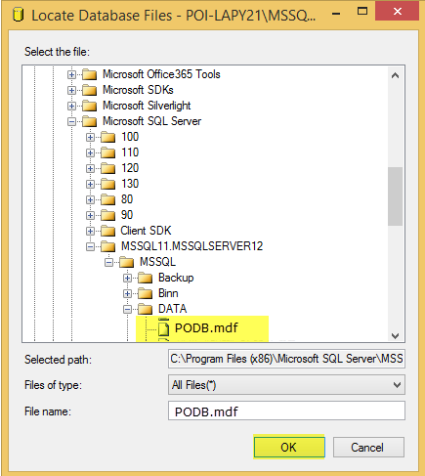

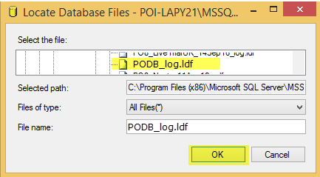

**Step 9:** Go to Options tab, select ‘Overwrite the existing database’ checkbox and clikc on OK button. Success message will then display.

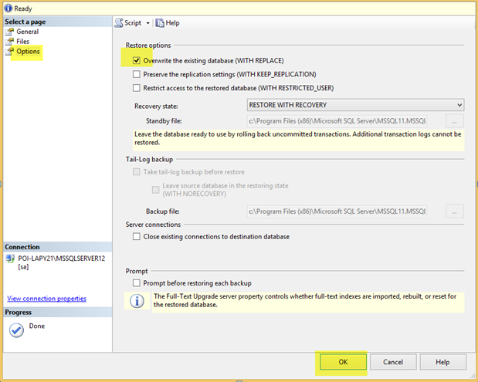

# Volt Database configuration

Below process need to be followed to configure VOLT Database:

**Step 1:** Open “SOL Server Management Studio”. A Pop-up will appear then click on “connect” to connect to the server. Enter SQL credentials to connect to SQL.



**Step 2:** Right click on “Database” menu at the left frame of the window. Then select “New Database”.



**Step 3:** Now enter the Database name and click on OK button.



**Step 4:** Right click on the Saved DB name > Select Task > Select Restore > Select Database. As shown in below screen:



**Step 5:** Restore Database window will open. Select **Device** and click on **Select Device** icon, this will open Select backup devices window as shown below:



**Step 6:** Click on the Add to select the location where database is saved. After database is selected click on OK button.

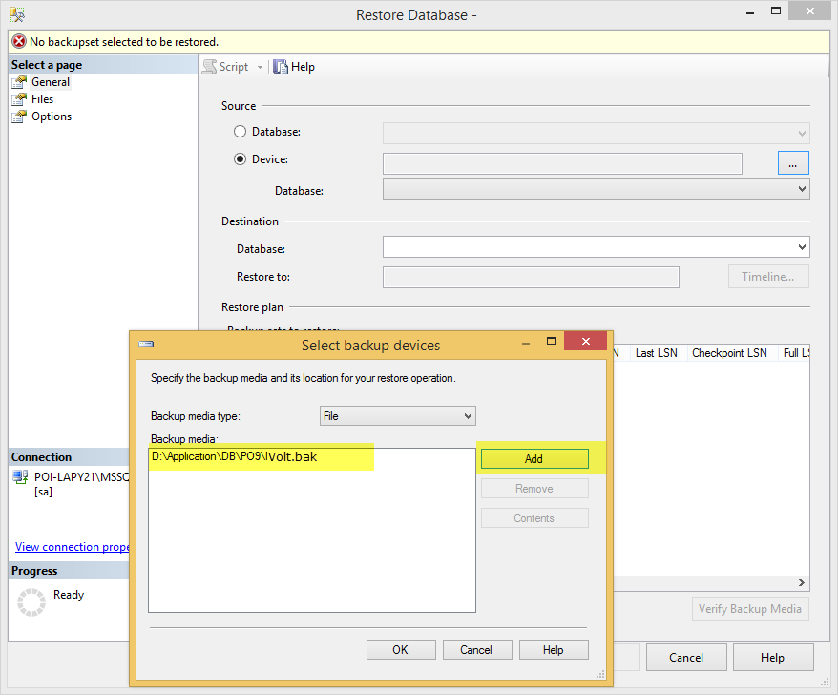

**Step 7:** In Database dropdown highlighted below, select the saved DB name to be configured. And check restore checkbox.

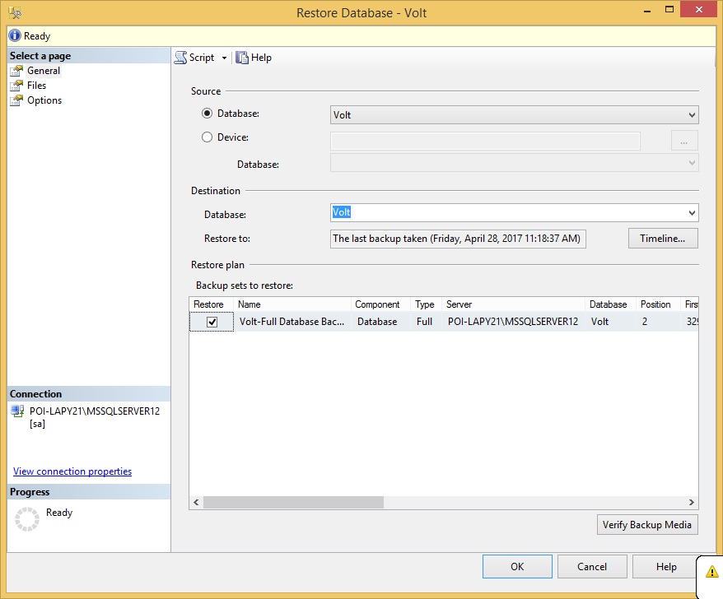

**Step 8:** Go to Files Tab and select respective location of .mdf file and .log file which is creation with same DB name.

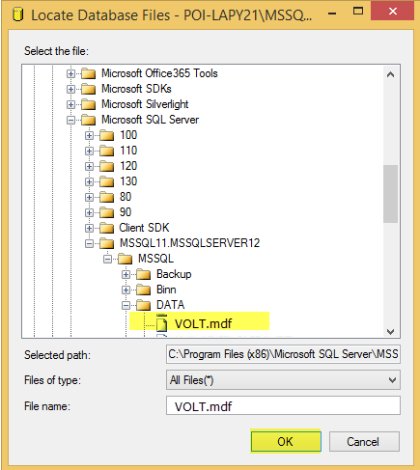

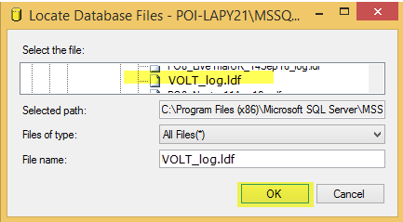

**Step 9:** Go to Options tab, select ‘Overwrite the existing database’ checkbox and clikc on OK button. Success message will then display.



# Web.Config Setting

Save SQL database connection details for both SPM and VOLT databases in Web.config file of Application.

